IOT ENABLED SMART FARMING

APPLICATION.

**Build A Web Application Using Node-RED**

TEAM ID : PNT2022TMID07522

# Configuration of Node-Red to collect IBM cloud data

The node IBM IOT App In is added to Node-Red workflow. Then the appropriate device credentials obtained earlier are entered into the node to connect and fetch device telemetry to Node-Red

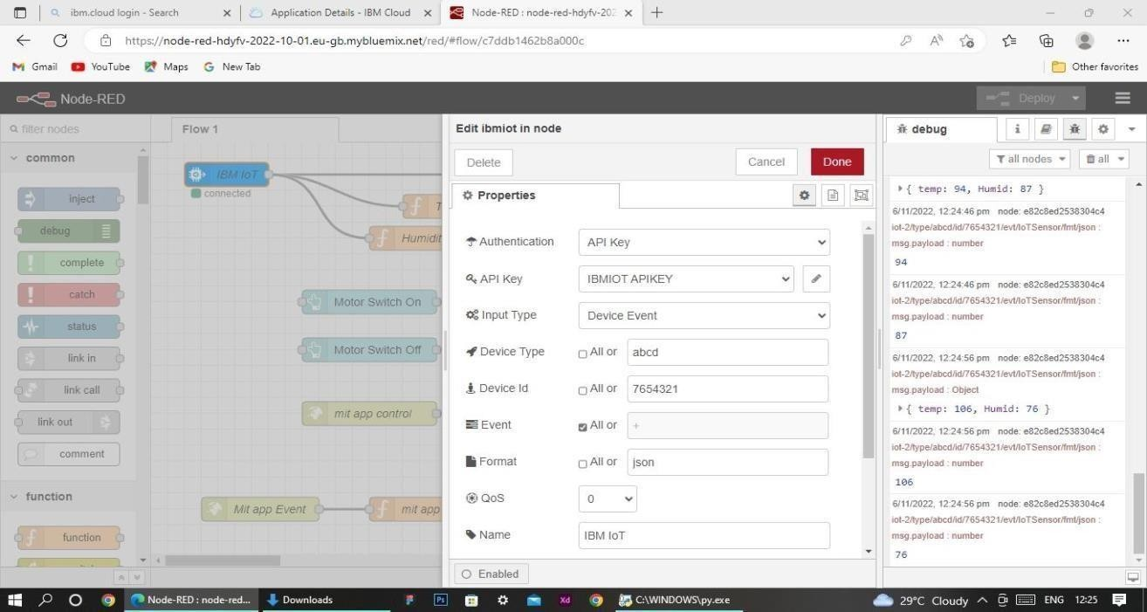

* Once it is connected Node-Red receives data from the device
* Display the data using debug node for verification
* Connect function node and write the Java script code to get each reading separately.
* The Java script code for the function node is: msg.payload=msg.payload.d.temperature return msg;
* Finally connect Gauge nodes from dashboard to see the data in UI

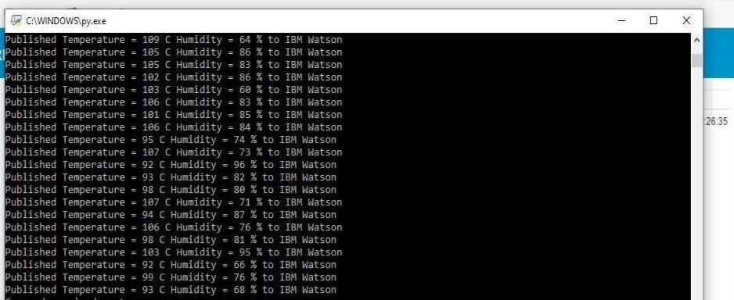

# Data received from the cloud in Node-Red console

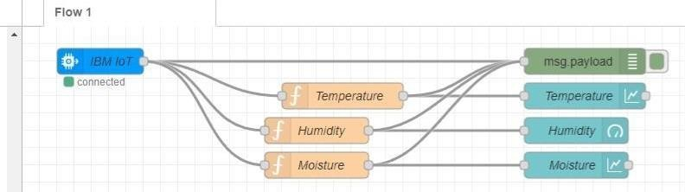

**Nodes connected in following manner to get each reading separately**

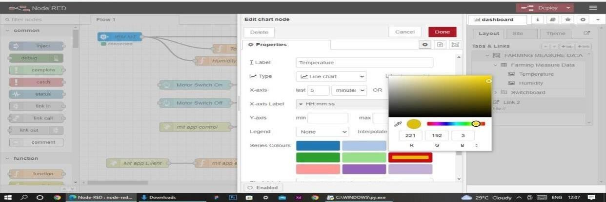

This is the Java script code I written for the function node to get Temperature separately.

# Configuration of Node-Red to collect data from Open Weather

* The Node-Red also receive data from the Open Weather API by HTTP GET request.An inject trigger is added to perform HTTP request for every certain interval.
* HTTP request node is configured with URL
* Thedata we receive from Open Weather after request is in below JSON

**format:**{"coord":{"lon":79.85,"lat":14.13},"weather":[{"id":803,"mai

n":"Clouds","description":"brokenclouds","icon":"04n"}],"base":"stati

ons","main":{"temp":30759,"feels_like":305.5,"temp_min":307.59,"te mp_max":307.59,"pressure":1002,"humidity":35,"sea_level":1002,"gr nd_level":1000},"wind":{"speed":6.23,"deg":170},"clouds":{"all":68

},"dt":1589991979,"sys":{"country":"IN","sunrise":1589933553,"sun

set":1589979720},"timezone":19800,"id":1270791,"name":"Gūdūr"," cod":20 0}

In order to parse the JSON string we use Java script functions and get each parameters

var temperature = msg.payload.main.temp; temperature = temperature-273.15;

return {payload : temperature.toFixed(2)};

In the above Java script code we take temperature parameter into a new variable and convert it from kelvin to Celsius

Then we add Gauge and text nodes to represent data visually in UI.

